**How to Use a Microcentrifuge**

A microcentrifuge is just what the name implies: a much smaller version of a centrifuge that can be kept on a tabletop (Fig. 1A-D). The control panel (Fig. 1B) will look slightly different from model to model, but all should have at least a control to change the speed and start or stop the spin. Models like the one shown in Fig. 1 will also have controls that allow you to change the time of the speed, the temperature, and toggle between rpm and rcf. Some microcentrifuges have lids on the rotor that will securely click in place; these will have instructions on how to open and close (Fig. 1C). Typically, the rotor accommodates an even number of 1.5-1.7ml polypropylene “microtubes” (Fig. 1D).

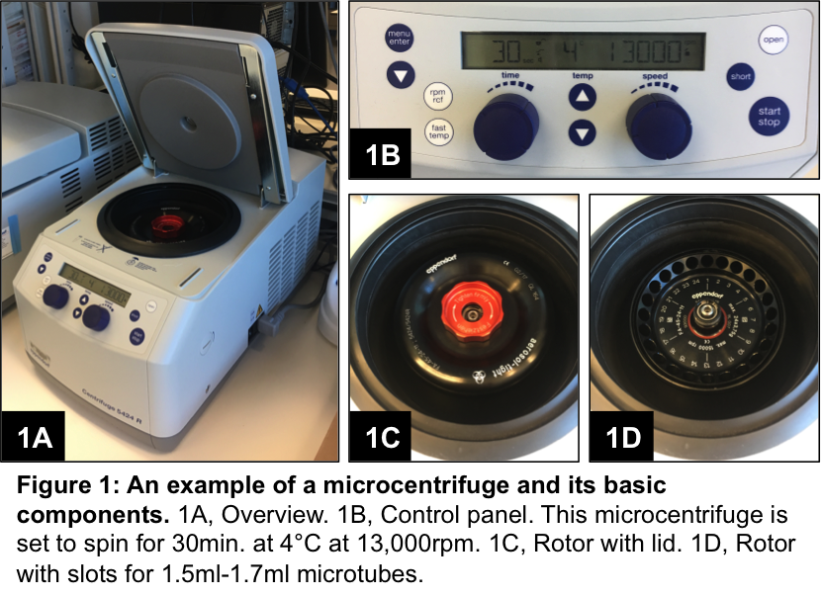

Before starting a spin, the tubes need to be balanced in order to spin properly. To balance the tubes, usually all you need to do is set tubes across from one another in a balanced way (Fig. 2). If the tubes need to spin at very high speeds, it is also a good idea to make sure each tube has roughly the same amount of volume of similar density liquid, or that the weights are roughly equivalent. For example, if you need to spin only one tube with 1ml of a cell suspension, make a balance by adding 1ml of water, PBS, or other aqueous buffer to an empty microtube and set it directly across from the tube with the cell suspension.

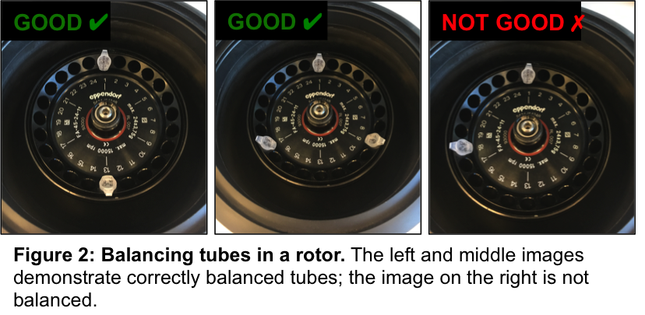

Let’s take the example of the 1ml cell suspension step by step. Let’s assume you need to pellet the cells by spinning them at 300xg for 5min. at 4°C.

1. Create a balance for the 1ml cell suspension by adding 1ml water to an empty 1.5ml microtube
2. Open the microcentrifuge and place the two tubes directly across from each other in the rotor
3. If the rotor has a lid, screw it on until it clicks in place; close the microcentrifuge
4. On the control panel, set the speed to 300xg
   1. Some models don’t have a setting for “xg”, but will instead have “rcf”; these are the same
   2. Some models will have “xg x 1000” in which case you would set it to 0.3 for 300xg
   3. Older models won’t even have “xg”, only rpm
   4. Check the type of rotor, look up the product info online and there should be a table to convert between “xg” or rcf and rpm
5. On the control panel, set the temperature to 4°C
   1. There may not be a temperature setting; instead, you can just keep the entire microcentrifuge chilled in a refrigerator for 4°C spins
   2. Some models have a feature called “Fast Temp”; this setting allows you to preset the empty microcentrifuge to your desired temperature before spinning your samples in it; just make sure the rotor is empty before doing “Fast Temp”, as it usually spins at very fast (~15,000rpm) speeds; after the “Fast Temp” spin is done, you are ready to start spinning your samples
6. On the control panel, set the time to 5min.
7. Start the spin
   1. You may have to press an “enter” button to confirm the settings before it will let you start
8. When the centrifuge is done spinning, open, unscrew the lid (if the rotor has a lid), and gently remove the tubes, without disturbing the cell pellet

If you need to spin the smaller 0.5-0.6ml microtubes, you can make an adaptor out of an empty 1.5ml microtube with the lid cut off (Fig. 3); simply place the smaller microtube in the larger one and you should be good to go.

